|  |  |
| --- | --- |
| **EXP NO : 7**  **DATE:** 15-03-23 | **MONGODB BASICS** |

**1. Study on MongoDB**

**Aim:**

To study about the basics of MongoDB and its operations.

**Theory:**

MongoDB is a general-purpose document database designed for modern application development and for the cloud. Its scale-out architecture allows you to meet the increasing demand for your system by adding more nodes to share the load.

MongoDB is a cross-platform, document-oriented database that provides, high performance, high availability, and easy scalability. MongoDB works on concept of collection and document.

**Document**

MongoDB stores data as JSON documents. The document data model maps naturally to objects in application code, making it simple for developers to learn and use. A document is a set of key-value pairs. Documents have dynamic schema. Dynamic schema means that documents in the same collection do not need to have the same set of fields or structure, and common fields in a collection's documents may hold different types of data. Documents can be nested to express hierarchical relationships and to store structures such as arrays.

**Collection**

Collection is a group of MongoDB documents. It is the equivalent of an RDBMS table. A collection exists within a single database. Collections do not enforce a schema. Documents within a collection can have different fields. Typically, all documents in a collection are of similar or related purpose.

id is a 12 bytes hexadecimal number which assures the uniqueness of every document. The first 4 bytes for the current timestamp, next 3 bytes for machine id, next 2 bytes for process id of MongoDB server and remaining 3 bytes are simple incremental VALUE.

**Sample document**

{

_id: ObjectId(“6418761848304d22ba39626b”),

emp_name: ‘Ram’,

emp_id: 1001,

age: 25,

dept: ‘Sales’

}

**Operations**

**1. Use**

To create and use a database. If the database exists, it returns existing database

use employee



**2. Create**

To create/insert a new document to a collection

**insertOne( )**

db.data.insertOne({emp_name:”Ram”,emp_id:1001,age:25, dept:”Sales”})

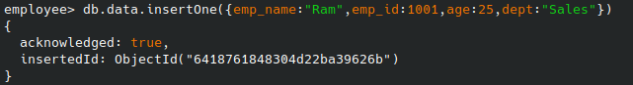

**insertMany( )**

db.data.insertMany([{emp_name:”Sam”,emp_id:1002,age:30,dept:”Accounts”},{emp_name:”Raju”,emp_id:1003,age:35,dept:”Management”},{emp_name:”Balu”,emp_id:1004,age:40,dept:”Production”}])

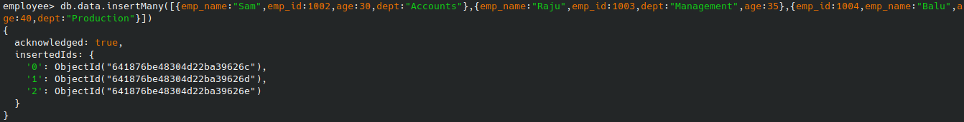

**3. Read**

To retrieve documents from a collection

db.data.find()

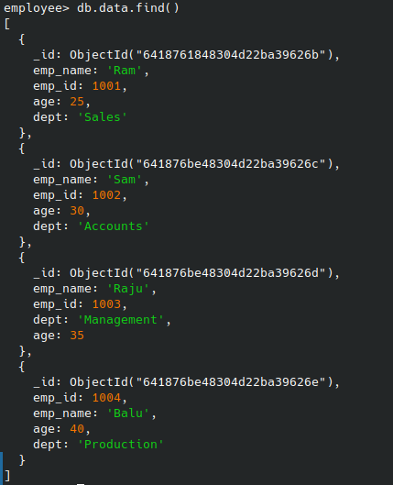

**4. Update**

To modify existing documents in a collection

db.data.updateOne({emp_id:1003},{$set:{age:50}})

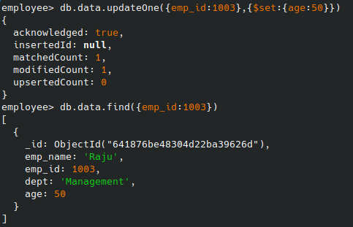

**5. Delete**

To remove documents from a collection

db.data.deleteMany({age:{$lt:38}})



**Result:**

A student management system has been designed using MongoDB and CRUD operations have been performed on it successfully.